**MILK GRADING SYSTEM**

Submitted by,

Antony Roshan K G

Abin Jose

**1.INTRODUCTION**

This high quality milk should be white in appearance, have no objectionable odors and free of abnormal substances such as pesticides, added water or antibiotic and antiseptic residues. Normal milk taken from high producing Holstein or Friesian dairy cows is composed of water (87%), fat (3.8%), proteins (3.4% of which 3/4 is casein), sugars (ie., lactose, 4.5%) and other solids such as minerals (1.3%). Milk also contains a quantity of minor components, including sloughed somatic cells. Somatic cells are composed of white blood cells (WBC) and occasional sloughed epithelial cells.

**1.1 OVERVIEW**

The milk quality is determined by its visual appearance, absence of adulterating substances and ability to meet specific quality standards for somatic cell count (SCC), and bacteria court. There exist several diagnostic tests of milk quality. Some of them are applicable on dairy farms, like for example, the California Mastitis Test (CMT) and the Milk Conductivity Test (MCT) Other tests, such as the bulk milk bacterial count, the bulk tank somatic cell count and tests for adulterants ke water, sediments or antibiotics, are used in laboratories. The knowledge required to successfully apply the existing milk quality tests can be rather extensive and pertains both to the methodology and the diagnostic capabilities of a given test. Therefore, there is a need for new simple and low-cost methods of milk quality testing. This paper presents a new method of milk quality classification using low-cost optical capillaries. In this method, milk quality is determined by observation of milk behavior under specific beating conditions using a simple low-cost photonic system with optical capillaries. We show that the optical capillary is a stable tool for analyzing liquids showing high scattering of light, such as milk.

**1.2 PURPOSE**

The main objective of the project is to milk processing allow the preservation of milk for days, weeks or months and help to reduce food-borne illness, the usable life of milk can be extended for several days through techniques such as cooling (which is the factor most likely to influence the quality of raw milk) or fermentation.

**2.LITERATURE SURVEY**

**2.1 EXISTING SYSTEM**

* The motor truck carrying the filled milk cans is backed up (or brought aside) to the unloading platform. The milk cans are then unloaded manually.
* The quality of the finished product depends on that of the raw material used. The milk grader is the key man for the proper selection of the milk.
* The importance of securing an accurate and representative sample of milk for subsequent chemical and bacteriological analysis cannot be over emphasized.

**2.2 PROPOSED SYSTEM**

* Smaller refrigeration is required for storing the milk
* The milk always stays cooler
* The best variant of the milk can be obtained which lasts longer

# 

**3.THEORITICAL ANALYSIS**

**3.1 BLOCK DIAGRAM**

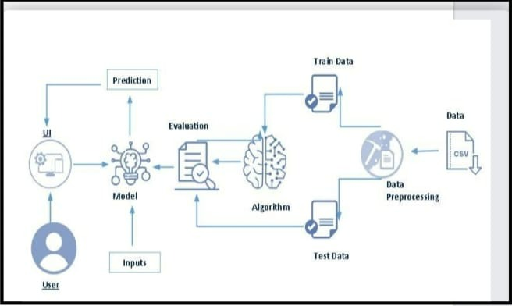

**3.2 HARDWARE / SOFTWARE DESIGNING**

The hardware required for the development of this project is:

Processor : Intel Corei3 7th Gen

Processor speed : 2.3GHz

RAM Size : 4 GB DDR

System Type : X64-based processor

**SOFTWARE DESIGNING**:

The software required for the development of this project is:

Desktop GUI : Anaconda Navigator

Operating system : Windows 10

Front end : HTML, CSS, JAVASCRIPT

Programming : PYTHON

Cloud Computing Service : IBM Cloud Services

**4.EXPERIMENTAL INVESTIGATION**

**IMPORTING AND READING THE DATASET**

**Importing the Libraries**

First step is usually importing the libraries that will be needed in the program.

**Pandas:** It is a python library mainly used for data manipulation.

**NumPy:** This python library is used for numerical analysis.

**Matplotlib and Seaborn:** Both are the data visualization library used for plotting graph which will help us for understanding the data.

**csr_matrix() :**A dense matrix stored in a NumPy array can be converted into a sparse matrix using the CSR representation by calling the csr_matrix() function.

**Train_test_split:** used for splitting data arrays into training data and for testing data.

**Pickle:** to serialize your machine learning algorithms and save the serialized format to a file.

**Reading the Dataset**

For this project, we make use of datasets (milk_grading.csv). We will be selecting the important features from these datasets that will help us in recommending the best results.

The next step is to read the dataset into a data structure that’s compatible with pandas.  
 Let’s load a .csv data file into pandas. There is a function for it, called **read_csv().** We will need to locate the directory of the CSV file at first (it’s more efficient to keep the dataset in the same directory as your program).If the dataset in same directory of your program, you can directly read it, without any path. After the next Steps we made following bellow:

1.Data visualization

2.Collabrative and filtering

3.Creating the Model

4.Test and save the model

5.Buil Python Code

6.Build HTML Code

7.Run the Application

**5.FLOWCHART**



Fig 5.1 Flowchart of the project

**Project Flow:**

1. User interacts with the UI (User Interface) to upload the input features.
2. Uploaded features/input is analyzed by the model which is integrated.

Once a model analyses the uploaded inputs, the prediction is showcased on the UI.

**1. Data Collection.**

* Collect the dataset or Create the dataset

**2. Data Pre- processing.**

* Import the Libraries.
* Importing the dataset.
* Exploratory Data Analysis
* Data Visualization

**3. Collaborating Filtering**

* Merging datasets
* Creating the Model
* Predicting the results
* Saving our model and dataset

**4. Application Building**

* Create an HTML file
* Build a Python Code

**6.RESULT**

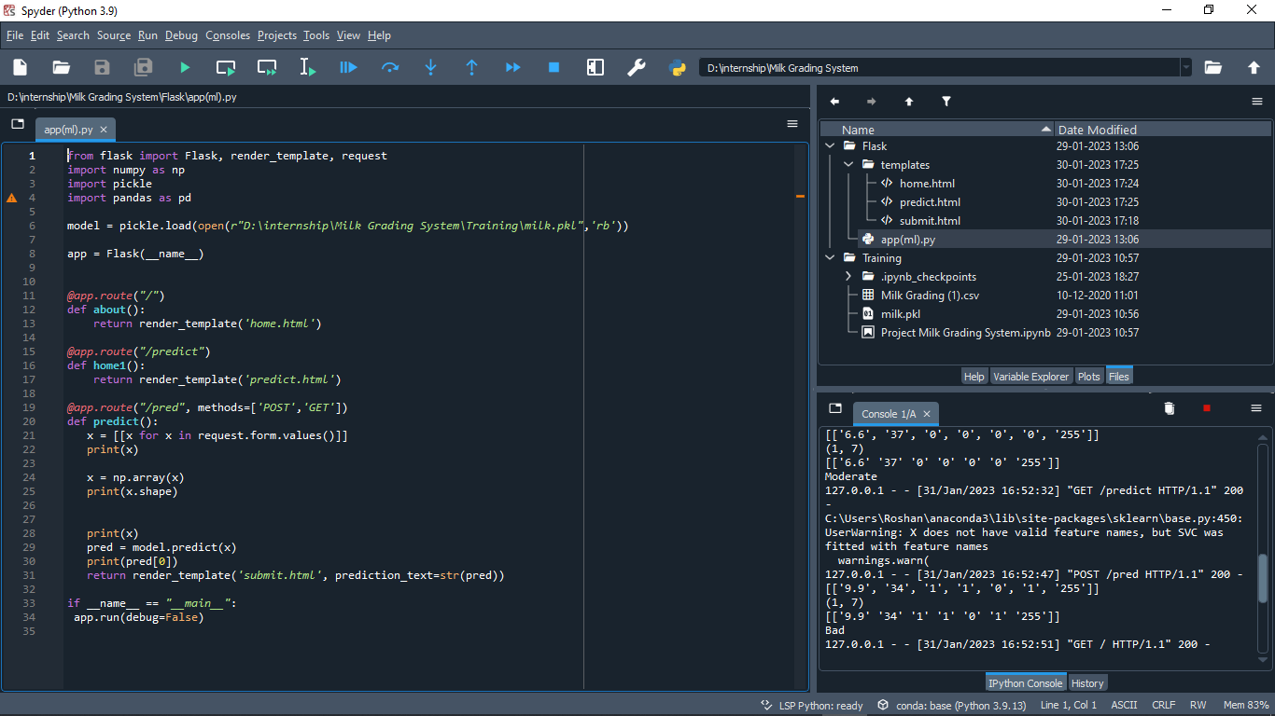

Fig 6.1 Flask code on Spyder

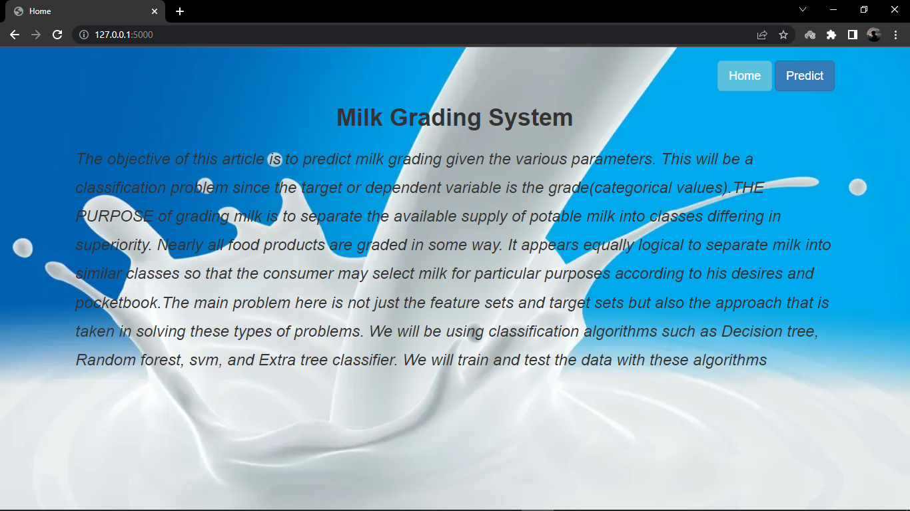

Fig 6.2 Home page for Milk Grading System

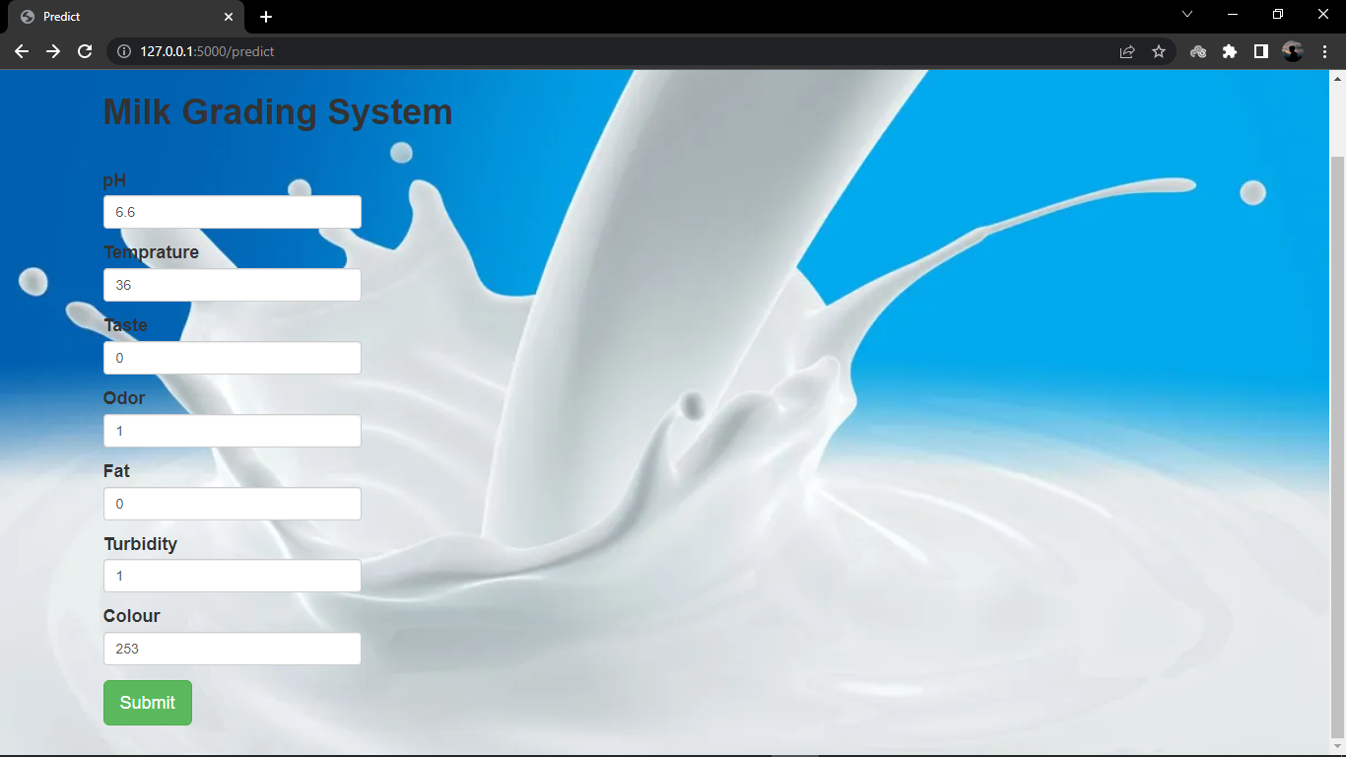 Fig 6.3 Predicting page of Milk Grading System



Fig 6.4 Output page of Milk Grading System

**7.ADVANTAGES AND DISADVANTAGES**

**ADVANTAGES**

* It Not only is the milk cooled, but it is also stays cool.
* A much smaller mechanical or much smaller mechanical refrigeration unit is required.

**DISADVANTAGES**

* It cools the milk very slowly.
* There is danger of milk contamination in case tank water enters milk-in-can.

**8.APPLICATIONS**

* Due to the nutritive value of milk, its testing and quality control is an essential component of any milk processing industry whether small, medium or large scale.
* Milk is made up of 87% of water hence making it prone to adulteration by unscrupulous middlemen and unfaithful farm workers.
* Milk processing allows the preservation of milk for days, weeks or months and helps to reduce food-borne illness.
* The usable life of milk can be extended for several days through techniques such as cooling (which is the factor most likely to influence the quality of raw milk) or fermentation.

**9.CONCLUSION**

Salty: Salty taste, which may be present in milk from cows in the late stages of lactation, is often characteristic of milk from cows infected with mastitis. It is not commonly found in herd milk or mixed milk received at a dairy plant. This defect cannot be detected by odor.

* Weedy: The weedy flavor is not included among the usual feed flavors. It generally has a bitter characteristic, varying with specific weeds of certain localities. It may include obnoxious flavors caused by such plants as ragweed, bitter-weed, or pepper grass, and may become a very troublesome flavor defect. It can be eliminated or minimized by keeping cows away from weed-infested pastures or by not offering feeds containing such weeds until after the cow is milked.

**10.FUTURESCOPE**

* From carrying-pails, the milk is poured directly into cans through a strainer. When the can is full, it is gently lowered into a tank/trough of cooling water.

**Enhancements that can be made in the future:**

* Milk may be delivered to the milk plant or dairy in cans or tankers. The milk in these containers has to be graded, emptied, measured by weight or volume, sampled and bulked to provide continuity of supply to the pasturing equipment.
* It is well known that the sanitary quality of milk on the receiving platform or dock depends on its background on the farm viz., healthy cows clean milk production, clean utensils, freedom from colostrum, prompt cooling and refrigerated transport. However, there is need for systematic and thorough inspection of all milk supplies everyday by conscientious and experienced milk graders.

**11.BIBILOGRAPHY**

* Hastie, Friedman, and Tibshirani, *The Elements of Statistical Learning*, 2001
* Bishop, *Pattern Recognition and Machine Learning*, 2006
* Ripley, *Pattern Recognition and Neural Networks*, 1996
* Duda, Hart, and Stork, *Pattern Classification*, 2nd Ed., 2002
* Tan, Steinbach, and Kumar, Introduction to Data Mining, Addison-Wesley, 2005.
* Scholkopf and Smola, *Learning with Kernels*, 2002

?**APPENDIX**

**A Source Code of Flask:**

from flask import Flask, render_template, request

import numpy as np

import pickle

import pandas as pd

model = pickle.load(open(r"D:\internship\Milk Grading System\Training\milk.pkl",'rb'))

app = Flask(__name__)

@app.route("/")

def about():

return render_template('home.html')

@app.route("/predict")

def home1():

return render_template('predict.html')

@app.route("/pred", methods=['POST','GET'])

def predict():

x = [[x for x in request.form.values()]]

print(x)

x = np.array(x)

print(x.shape)

print(x)

pred = model.predict(x)

print(pred[0])

return render_template('submit.html', prediction_text=str(pred))

if __name__ == "__main__":

app.run(debug=False)